The paper’s title should accurately describe the content of the paper in a few words (Center, 24pt)

Team Name
Author’s name^{1*}, Author’s name²
¹Author’s Affiliation, Country (Do not use abbreviation form)(use asterisk to indicate corresponding author)
²Author’s Affiliation, Country (Do not use abbreviation form)
Abstract— An abstract should provide a concise and accurate summary of the manuscript's content. Additionally, the abstract should be informative and self-explanatory. It should clearly state the problem, the proposed approach, major findings, and conclusions. Moreover, the abstract should be between 100 and 250 words in length, bold, and in 9pt font.

Keywords— First keyword, second keyword, third keyword, fourth keyword, fifth keyword.

INTRODUCTION
This template offers comprehensive descriptions of the relevant information pertaining to the paper format. The introduction should present a clear background, a precise statement of the problem, a thorough review of the pertinent literature, the proposed solution or approach, and the novelty of the paper.

Main Title
The main title should be positioned beneath the header at the top of the page, centered, and set in Times New Roman 24pt. Furthermore, the initial letter of verbs, pronouns, nouns, adjectives, and adverbs should be capitalized. However, articles, coordinating conjunctions, and prepositions (unless the title commences with such a word) should remain in lowercase.

Main Text
The main body of the text should be written in 10pt Times New Roman, with single line spacing. Each paragraph should be indented by 0.5 times the character size. The text must be fully justified, ensuring alignment of both the left and right margins. Blank lines should not be inserted between paragraphs

First-order headings
First-order headings should be set in Times New Roman 10pt, centered, and preceded by a Roman numeral, as outlined in the headings above.

Second-order headings
Second-order headings should be formatted in Times New Roman 10pt, with initial capitalization, aligned to the left, italicized, and preceded by a word, as indicated in the headings above.

A.1. Third-order headings
Third-order headings should adhere to the same format as second-order headings, with the inclusion of a number following the word, as demonstrated in the headings above.

Figures and Tables
Tables and figures should be integrated within the text, ensuring that sufficient space is maintained between the text and the captions to prevent any confusion. In the manuscript, figures should be referred to as Fig. 1, Fig. 2, and so on, while tables should be referred to as Table 1, Table 2, etc.
The captions for both figures and tables must be formatted in Times New Roman, 9pt. The initial letter of each figure and table caption should be capitalized. Captions for figures should be positioned below the figure and centered, whereas captions for tables should be placed above the table. An example of the proper formatting of figures and tables within the text is provided below.
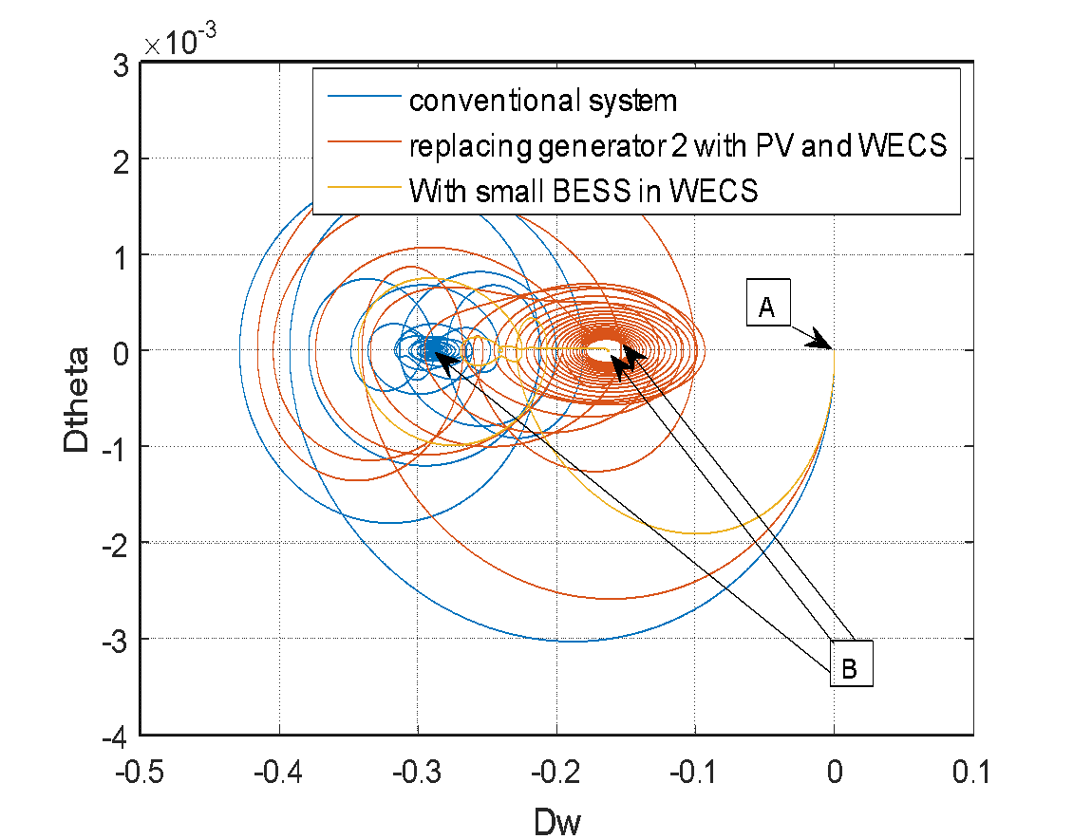
(a)

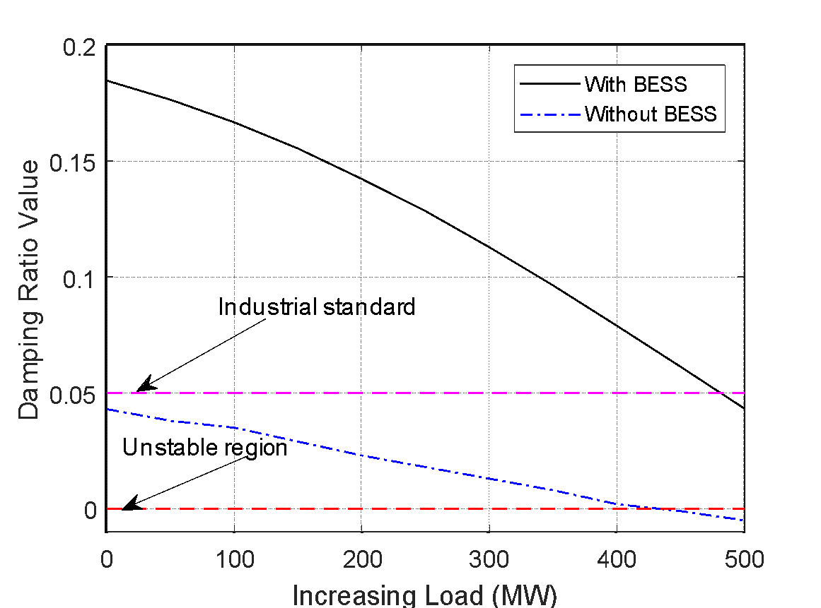
(b)
Figure. 1 Response system: (a) top figure and (b) bottom figure

Table 1. Overshoot value
Overshoot | Settling time
0.00001 | 10
* In figures and tables, the font size is 9pt.

Equations
The symbols in equations should be defined either prior to the appearance of the equation or immediately following it. When referring to an equation or formula, simply use “(1),” rather than “Eq. (1)” or “equation (1),” unless at the beginning of a sentence, in which case it should be written as “Equation (1) is ... .” An example of proper equation formatting is provided below
B_{p} + H₂ = 40. (1)

Conclusion

A conclusion section is not mandatory. While the conclusion may serve to review the main points of the article, it should not duplicate the abstract. Instead, the conclusion may provide further elaboration on the significance of the work or propose potential applications and extensions.
Appendix
Appendixes, if needed, should appear before the acknowledgment section.
Acknowledgment
Acknowledgments are to recognize the support provided by any organizations or entities contributing to the article.
References
References should be formatted in Times New Roman, 8pt, and placed subsequent to the acknowledgments section. When citing references, numbers should be presented in square brackets, e.g., [1]. When citing multiple references simultaneously, the corresponding numbers should be enclosed within a single set of brackets. It is imperative that all references are appropriately cited within the body of the text.
[1] K. N. Hasan, R. Preece, "Influence of stochastic dependence on small-disturbance stability and ranking uncertainties," IEEE Trans. Power Systems, vol. 33, no. 3, pp. 3227-3235, 2018. (In the case of Journal Papers)
[2] Y. Zou, J. He, "Comprehensive modeling, simulation and experimental validation of permanent magnet synchronous generator wind power system," in IEEE/IAS 52nd Industrial and Commercial Power Systems Technical Conference (I&CPS), Detroit, USA, 2016. (In case of Journal Papers)
[3] K. Clark, N. W. Miller, and R. Walling, "Modelling of GE solar photovoltaic plants for grid studies," General Electrical International, Inc., Schenectady, NY2010. (In case of report)
[4] R. J. Hijmans and J. van Etten, “Raster: Geographic analysis and modeling with raster data,” R Package Version 2.0-12, Jan. 12, 2012. [Online]. Available: http://CRAN.R-project.org/package=raster (In case of book)

